1st DAKSHANAMURTHI S
Artificial Intelligence and Data Science
S.A. Engineering College
Chennai, India
2324020@saec.ac.in
3rd HEMANTH KUMAR M P
Artificial Intelligence and Data Science
S.A. Engineering College
Chennai, India
2324032@saec.ac.in
2nd DHANUSH A
Artificial Intelligence and Data Science
S.A. Engineering College
Chennai, India
2324023@saec.ac.in
4th Muthu Kumar G
Artificial Intelligence and Data Science
S.A. Engineering College
Chennai, India
muthukumarg79.cse@gmail.com

Abstract—The rapid advancement of Artificial Intelligence (AI), Internet of Things (IoT), and Digital Twin technologies has enabled the development of intelligent and sustainable building infrastructure. Smart buildings require continuous monitoring of environmental conditions, energy consumption, equipment performance, and occupant safety to ensure efficient operation. Existing building management systems primarily rely on IoT sensors to collect real-time data and display it through centralised dashboards. Although these systems provide basic monitoring and visualisation, they mainly support reactive management and lack intelligent analytics, predictive capabilities, anomaly detection, and decision support. To address these limitations, this paper presents an AI-Powered Digital Twin for Intelligent Building Monitoring and Predictive Management. The proposed system creates a virtual representation of a physical building by integrating IoT-based environmental sensing, Artificial Intelligence, cloud computing, and data analytics. A FastAPI backend manages sensor data and communication, MongoDB stores data, and a web-based dashboard enables interactive building visualisation and room-level monitoring. Multiple Machine Learning models analyse temperature, humidity, gas, and occupancy data to support occupancy prediction, gas-related analysis, abnormal condition identification, and AI-based insights. The system provides real-time sensor visualisation, room condition assessment, and warnings when monitored values exceed defined limits. By combining Digital Twin technology with Machine Learning, the proposed framework enhances conventional monitoring with predictive analytics and intelligent decision support. It provides a scalable foundation for proactive maintenance, improved occupant safety, operational efficiency, and future integration of physical sensors with real-time synchronisation between the physical building and its virtual representation, contributing to the development of safer, more efficient, and sustainable smart buildings.
Keywords—Artificial Intelligence, Digital Twin, Smart Building, Machine Learning, Predictive Analytics, IoT, Intelligent Building Monitoring

Introduction
The increasing use of Artificial Intelligence (AI), Internet of Things (IoT), and Digital Twin technologies has created new opportunities for intelligent building monitoring. IoT sensors can collect real-time environmental information from different rooms, while a Digital Twin provides a virtual representation of the physical building. The integration of these technologies supports continuous observation of building conditions and improves the availability of information for building management [1]. Recent research has investigated the use of AI, Digital Twins, and IoT for sustainable building design and intelligent construction monitoring [2], [3]. IoT-driven machine learning systems have also been proposed for real-time monitoring in smart buildings [4].

Conventional building monitoring systems mainly display sensor values through dashboards and generate alerts when predefined limits are exceeded. Although these systems are useful for observing building conditions, they provide limited support for interpreting sensor data and identifying abnormal patterns. AI and Digital Twin technologies have been studied for building energy management and indoor environmental analysis [5], [6]. Other research has considered thermal comfort and occupant interaction in smart buildings [7], [8]. However, many existing approaches focus on a particular parameter or application rather than combining multiple room-level monitoring functions in a single platform.

Machine Learning (ML) models can support building monitoring by learning patterns from collected sensor data and identifying unusual conditions. Previous studies have applied deep learning and Digital Twin technologies to indoor temperature prediction and environmental forecasting [9], [10]. These approaches demonstrate the potential of AI for analysing building data and supporting intelligent management. This work presents an AI-Powered Digital Twin for intelligent building monitoring and predictive management. The proposed system is designed to monitor room-level temperature, humidity, gas, and occupancy data. A FastAPI-based backend is used to process the data, while MongoDB provides data storage, and a web-based dashboard presents the current condition of each room. Multiple ML models are integrated to support occupancy analysis, gas-related analysis, and abnormal-condition identification. The system also provides AI-based insights and warning messages when sensor values indicate potentially unsafe or unusual conditions. Physical sensor synchronisation and hardware-based validation are considered as future extensions of the system.
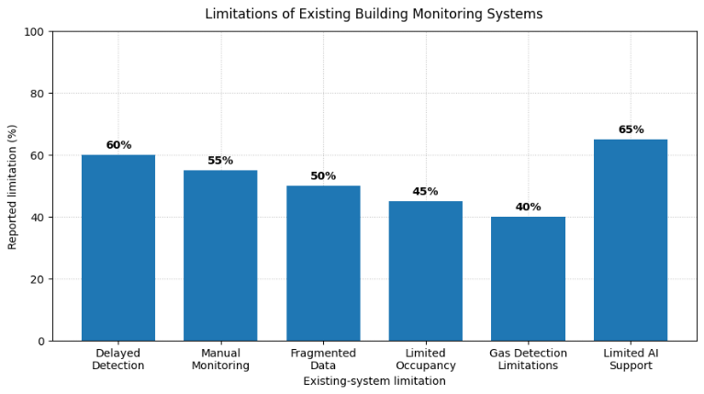
The major limitations reported in existing building monitoring studies are statistically summarised in Fig. 1. The graph highlights the need for integrated monitoring, timely abnormal-condition detection, and intelligent decision support in conventional building monitoring systems.
- Limitations of existing building monitoring systems.

Related works
Recent research has explored the integration of Artificial Intelligence (AI), Internet of Things (IoT), and Digital Twin technologies for intelligent building monitoring [11]. AI- and IoT-based systems collect real-time sensor data and support the monitoring of indoor environmental conditions [12]. Digital Twin-based approaches create virtual representations of physical buildings by integrating building information with sensor data and visualisation techniques [13]. Machine Learning (ML) methods have also been applied to analyse sensor data, identify patterns, and detect abnormal building conditions [14]. However, many existing systems are designed for specific applications, such as energy management, environmental monitoring, gas detection, or occupancy analysis [15].
Other studies have investigated indoor environmental assessment, thermal comfort monitoring, occupancy detection, deep learning-based prediction, and AI-assisted building management [16]. These approaches demonstrate the potential of intelligent models to improve building monitoring and decision-making [17]. Nevertheless, several systems require extensive historical data, depend on complex infrastructure, or provide limited support for real-time warnings [18]. In addition, environmental monitoring, occupancy analysis, and safety-related detection are often implemented as separate functions [19]. The proposed system addresses these limitations by integrating room-level temperature, humidity, gas, and occupancy monitoring with multiple ML models, abnormal-condition identification, warning generation, and AI-based insights in a single software platform [20]. The comparison of the selected studies, including their objectives, methods, and limitations, is presented in Table I.
Article Title | Key Objective | Methods Used | Limitation
AI-Enabled Digital Twin Framework for Climate-Responsive and Sustainable Building Design | To support climate-responsive and sustainable building design using AI and Digital Twin technologies | Artificial Intelligence, Digital Twin framework, building design analysis | Focuses mainly on sustainable building design rather than integrated real-time room monitoring
Design of Intelligent Construction Monitoring System for Building Engineering Based on Digital Twin, BIM, Computer Vision, and IoT Technologies | To improve construction monitoring through the integration of building information and real-time data | Digital Twin, BIM, Computer Vision, IoT | Mainly focuses on construction monitoring and may not provide complete operational monitoring
Embedded Machine Learning Gas Detection System Using ESP32 and BLE | To detect hazardous gases using an embedded machine learning system | ESP32, gas sensor array, Machine Learning, BLE | Limited to gas detection and does not monitor other building parameters
An IoT-Driven Machine Learning Framework for Real-Time Monitoring in Smart Buildings | To monitor smart-building conditions using IoT and Machine Learning | IoT sensors, real-time monitoring, Machine Learning | May focus on selected sensor parameters and provide limited Digital Twin visualization
Optimizing Building Performance: A Novel Digital Twin Framework for Enhanced Thermal Comfort | To improve building performance and occupant thermal comfort | Digital Twin, environmental monitoring, thermal comfort analysis | Focuses mainly on thermal comfort rather than integrated gas, occupancy, and abnormal-condition monitoring
- Recent Studies on AI-Based Digital Twin Building Monitoring

Methodology
This section describes the development process of the proposed AI-based Digital Twin building monitoring system, including system architecture, sensor data acquisition, communication, data processing, machine learning analysis, and dashboard visualisation. The methodology integrates room-level environmental and occupancy information into a unified monitoring platform. The overall system architecture and proposed workflow are presented in Fig. 1 and Fig. 2, respectively.

System Architecture
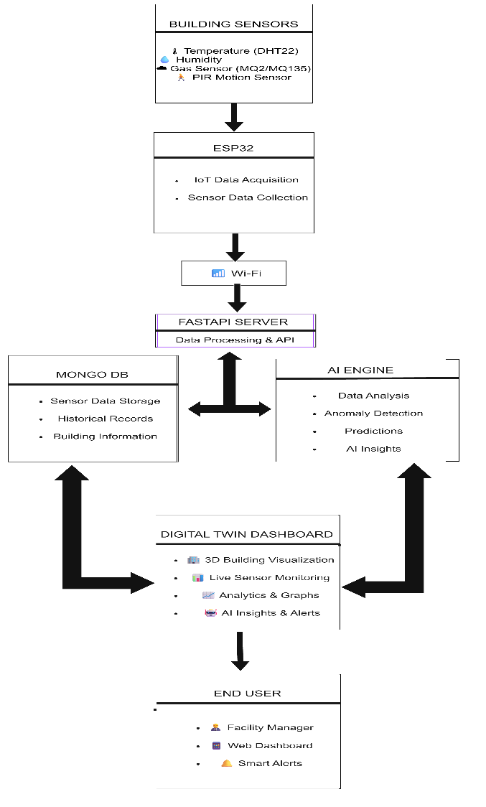
The proposed system consists of five layers: the Hardware Layer, Communication Layer, Backend Layer, Application Layer, and User Layer. The Hardware Layer includes temperature, humidity, gas, and PIR motion sensors connected to an ESP32 microcontroller. The ESP32 performs sensor data acquisition and prepares the collected readings for transmission. The Communication Layer transfers sensor data through Wi-Fi using MQTT/HTTP communication. The Backend Layer consists of a FastAPI server and MongoDB database, which manage data processing, storage, and communication with the AI engine and dashboard. The AI Engine analyses sensor data using the developed Machine Learning models for data analysis, abnormal-condition detection, and prediction where applicable. The Application Layer provides the Digital Twin dashboard for real-time monitoring, analytics, alerts, and historical data visualisation, while the User Layer enables the facility manager or administrator to observe building conditions and support building management decisions. The overall system architecture is illustrated in Fig. 2.
- Proposed five-layer architecture for AI-based Digital Twin building monitoring.

Sensor Data Acquisition
The system is designed to monitor room-level environmental and occupancy conditions using temperature, humidity, gas, and PIR motion sensors. Temperature and humidity sensors provide information about indoor environmental conditions, while the gas sensor measures changes in gas concentration. The PIR motion sensor provides occupancy-related information. The ESP32 collects the sensor readings and associates them with the corresponding room and timestamp. The collected data are prepared for transmission to the backend server through the communication layer, enabling the continuous availability of room-level information for storage and further analysis.

Data Communication and Processing
The collected sensor data are transmitted from the ESP32 to the FastAPI server through Wi-Fi communication. The backend receives the data, validates the incoming values, and prepares them for storage and analysis. The processed records are stored in MongoDB along with room information and historical readings. The backend also manages communication between the database, AI engine, and frontend dashboard. This arrangement allows the same sensor data to be used for historical analysis, machine learning inference, and real-time visualisation.

Machine Learning Analysis
Multiple Machine Learning models are developed for different monitoring tasks. The occupancy model analyses the available sensor features to identify occupancy conditions, while the gas-related model processes gas sensor readings to support hazardous-condition detection. Additional models analyze environmental parameters to identify abnormal room conditions. The models are trained using their corresponding datasets and evaluated using suitable performance measures. After training, the models are integrated into the backend for inference on newly received sensor values. The resulting outputs are used to support abnormal-condition identification and AI-based insights.

Digital Twin Dashboard
The Digital Twin dashboard provides a virtual representation of the monitored building and its room-level conditions. The dashboard displays live sensor readings, analytical graphs, historical data, model outputs, and system alerts. This visualization allows users to observe building conditions through a unified interface. The dashboard receives processed information from the backend and presents it in an understandable form. When an abnormal condition is identified, the corresponding warning is displayed for the relevant room. The dashboard therefore acts as the primary interface between the monitoring system and the facility manager.

Proposed Workflow
The proposed workflow begins with sensor data acquisition from the building environment. The ESP32 collects the readings and transmits them through Wi-Fi to the FastAPI server. The backend processes the received data and stores the records in MongoDB. The processed data are then forwarded to the AI engine for analysis using the developed Machine Learning models. The analysis results are used to identify abnormal conditions, generate predictions where applicable, and provide AI-based insights. Finally, the processed information is displayed on the Digital Twin dashboard through real-time monitoring, analytics, and alerts. The facility manager can use the displayed information to monitor room conditions and support building management decisions. The complete workflow is presented in Fig.3.
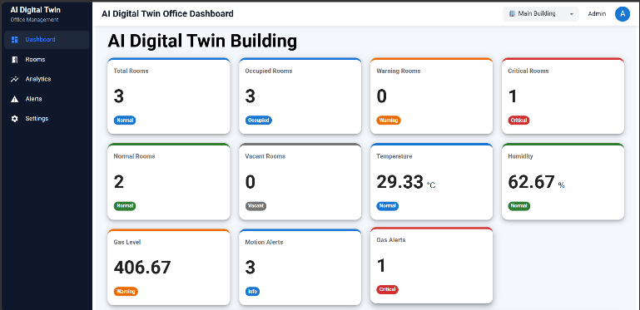
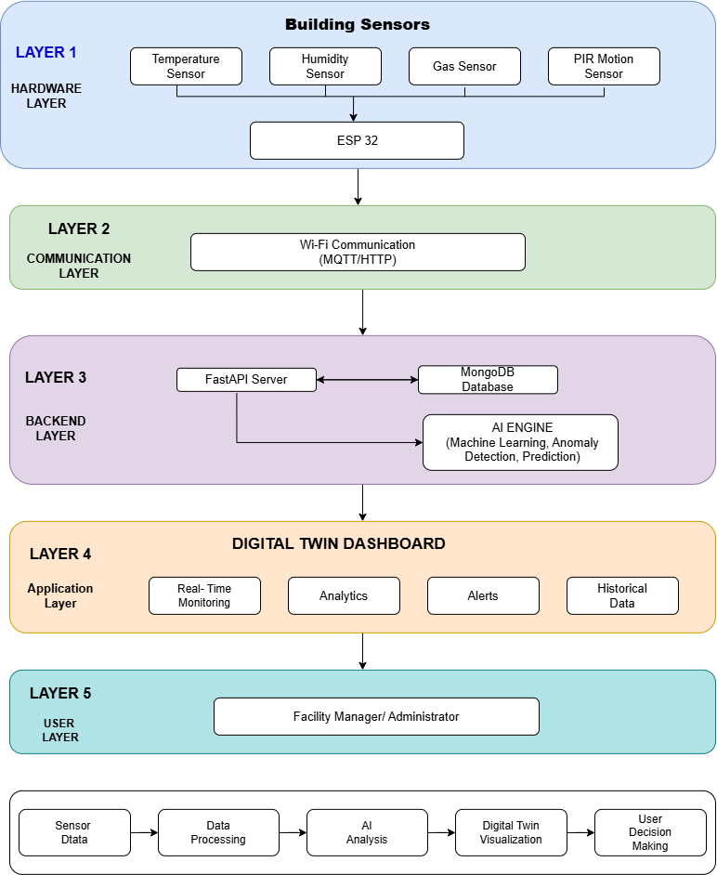

- Proposed work-block diagram showing the flow from sensor data acquisition to user decision-making.

Experimental setup and results
This section describes the hardware and software implementation of the proposed AI-based Digital Twin system and presents the experimental observations obtained from the developed smart-office monitoring platform. The system was implemented for a three-room office environment consisting of a Reception, Manager Cabin, and Workspace. Temperature, humidity, gas-level, and occupancy information were collected and processed through the backend, while the web dashboard was used to visualize room conditions, historical trends, alerts, and AI-generated insights.

Hardware Setup
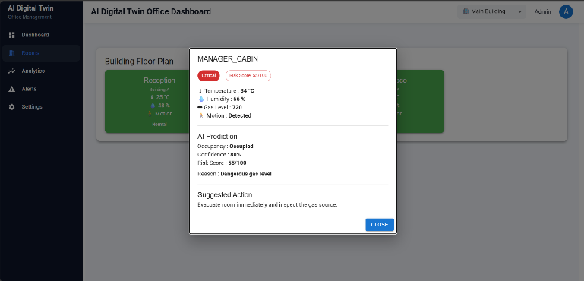
The hardware setup consists of an ESP32 microcontroller, DHT22 temperature and humidity sensors, an MQ-2 gas sensor, PIR motion sensors, and a buzzer for alert indication. The DHT22 sensors measure the temperature and relative humidity of each monitored room, while the MQ-2 sensor detects changes in gas concentration. PIR sensors provide motion-based occupancy information, and the buzzer provides an audible indication when a critical condition is detected. The sensors are connected to the ESP32 using jumper wires and a breadboard-based circuit. The ESP32 collects the sensor readings and transfers them to the backend through Wi-Fi communication. The hardware setup supports the acquisition of room-level data required for environmental monitoring, occupancy analysis, and abnormal-condition detection.
Components Used: ESP32 microcontroller, DHT22 temperature and humidity sensors, MQ-2 gas sensor, PIR motion sensors, buzzer, power supply, breadboard, and jumper wires.

Software Implementation
The software implementation consists of a FastAPI backend, MongoDB database, machine learning models, and a React-based web dashboard. The FastAPI backend receives sensor data, validates the incoming values, stores the records in MongoDB, and communicates with the machine learning modules. The developed machine learning models analyze occupancy information, gas-related conditions, and environmental parameters to identify abnormal room conditions. The React frontend presents the processed information through building-level and room-level dashboards. The system also provides analytics, alerts, and AI-generated insights to support monitoring and decision-making. The main dashboard displays the total number of rooms, occupied rooms, warning rooms, critical rooms, temperature, humidity, gas level, and motion alerts, as shown in Fig. 4.

- Main dashboard showing building-level monitoring information.

Experimental Workflow
The experimental workflow begins with the initialisation of the sensors and ESP32 microcontroller. The sensor readings are collected from the monitored rooms and transmitted to the FastAPI backend through Wi-Fi. The backend processes the received data and stores the readings in MongoDB with the corresponding room information and timestamp. The stored data are then provided to the machine learning models for occupancy analysis, gas-condition analysis, and abnormal-condition identification. The results are sent to the frontend, where they are displayed through room cards, status indicators, and sensor values. The room-level dashboard provides individual temperature, humidity, gas-level, occupancy, and safety-status information for the Reception, Manager Cabin, and Workspace, as shown in Fig. 5.
- Room-level Digital Twin dashboard showing environmental and occupancy conditions.

Results and Discussion
The developed system successfully displayed room-level sensor information and building-level status through the Digital Twin dashboard. The room-level results show that the Reception recorded a temperature of 25 °C, humidity of 48%, and gas level of 180, while the Manager Cabin recorded 34 °C, 66% humidity, and a gas level of 720. The Workspace recorded 29 °C, 74% humidity, and a gas level of 320. The Manager Cabin was identified as a critical room because of its higher temperature and gas-level readings, whereas the Reception and Workspace were marked as safe. These results demonstrate that the system can distinguish between normal and abnormal room conditions using sensor data and machine learning analysis. The room-wise environmental and safety conditions are presented in Fig. 5.

Historical Data Analysis
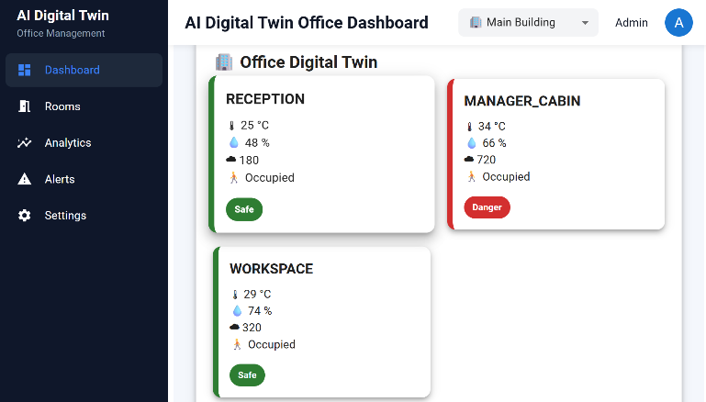
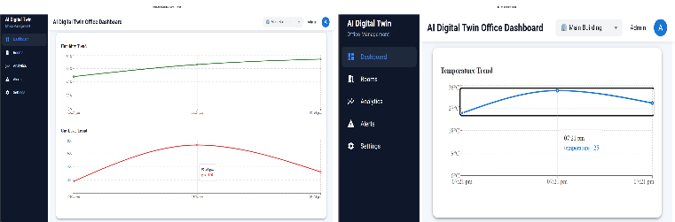
The analytics module provides graphical representations of the stored sensor readings for identifying changes in room conditions over time. The temperature trend shows variations between approximately 25 °C and 34 °C, while the humidity trend increases from approximately 48% to 74%. The gas-level trend shows a variation from approximately 180 to 720, indicating a significant change in the measured gas condition during the observation period. These trends allow the facility manager to examine historical sensor behaviour and identify unusual changes that may require further inspection. The temperature, humidity, and gas-level trends generated by the system are shown in Fig. 6.
- Analytics dashboard showing temperature, humidity, and gas-level trends.

Alerts and AI Insights
The alert and AI Insights module provides information about the current condition of the monitored building. The system generates warnings when sensor values exceed the configured normal range or when the machine learning analysis identifies a critical condition. The AI Insights interface summarises the status of temperature, humidity, air quality, and overall building health in a user-readable format. During normal operation, the interface displays messages indicating that the temperature, humidity, and air quality are normal. The alert interface also supports the display of critical conditions, such as abnormal gas levels or excessive temperature, thereby helping the facility manager respond to unsafe room conditions. The alerts and AI-generated building-status messages are presented in Fig. 7.

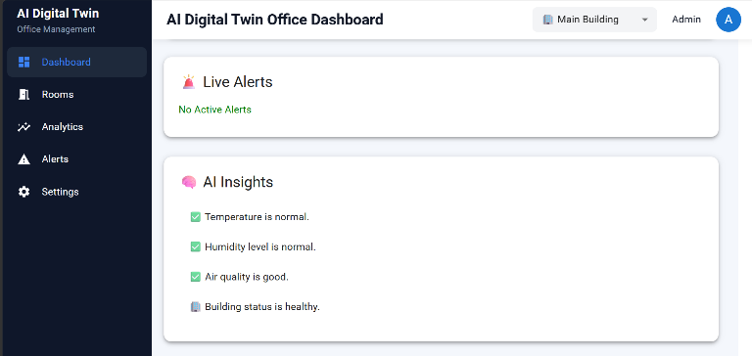
- Alerts and AI Insights interface for abnormal-condition monitoring.

Digital Twin Floor-Plan Visualization
The floor-plan module provides a virtual representation of the monitored office building by displaying the status of each room using colour-coded indicators. The Reception and Workspace are represented as normal rooms, while the Manager Cabin is highlighted as a critical room because of its abnormal environmental readings. The floor-plan visualization combines room identification, temperature, humidity, motion status, and safety condition in a single interface. This representation enables the facility manager to identify the location of an abnormal condition without examining every room individually. The building floor plan and room-wise status visualization are shown in Fig. 8.
- Building floor plan showing room-wise environmental status.

Summary of Experimental Results
The experimental implementation demonstrates the integration of sensor data acquisition, backend processing, machine learning analysis, database storage, and Digital Twin visualization in a unified software platform. The system provides building-level monitoring, room-level environmental information, historical analytics, abnormal-condition warnings, AI-generated insights, and colour-coded floor-plan visualization. The observed results confirm that the proposed platform can support real-time monitoring and assist facility managers in identifying critical room conditions. The system can be extended in future work by incorporating additional rooms, more sensor types, larger historical datasets, and advanced predictive models.

- Challenges Encountered and Solutions Implemented
S. No. | Challenge Encountered | Solution Implemented
1 | Collecting sensor data from multiple rooms | An ESP32-based sensor node was used to collect environmental and occupancy data.
2 | Transferring sensor data to the backend | Wi-Fi communication was implemented between the ESP32 and FastAPI backend.
3 | Managing data from different rooms | Each sensor reading was stored with its room identifier and timestamp in MongoDB.
4 | Detecting abnormal room conditions | Machine learning models and predefined threshold values were used to identify abnormal conditions.
5 | Displaying real-time monitoring information | A React-based dashboard was developed to display building-level and room-level conditions.
6 | Providing understandable warnings | Alerts, AI-generated insights, and colour-coded floor-plan indicators were implemented to support quick decision-making.

Table II summarises the main implementation challenges and the corresponding solutions used to integrate the sensing, communication, data-processing, and visualization components. These solutions helped establish a unified Digital Twin platform for reliable room-level monitoring and abnormal-condition detection.

Conclusion
This study developed an AI-based Digital Twin system for intelligent monitoring of a smart office environment. The proposed system integrates ESP32-based sensors, a FastAPI backend, a MongoDB database, machine learning models, and a React-based web dashboard to monitor temperature, humidity, gas level, and occupancy across multiple rooms. The developed platform provides building-level and room-level monitoring, historical data analysis, abnormal-condition detection, alerts, AI-generated insights, and floor-plan visualization. The experimental results demonstrate that the system can identify abnormal environmental conditions and highlight critical rooms for timely attention. Future work will focus on expanding the system to additional rooms, integrating more sensor types, improving model performance using larger datasets, and incorporating advanced predictive models for energy optimization and early fault detection.

References

- M. F. Anwar, F. Waseem, M. Haque, M. A. Khan, and N. Abid, "AI-Enabled Digital Twin Framework for Climate-Responsive and Sustainable Building Design," in Proc. Int. Conf. on Frontiers of Engineering and Emerging Technologies (FET), IEEE, 2026.
- X. Zhang, "Design of Intelligent Construction Monitoring System for Building Engineering Based on Digital Twin, BIM, Computer Vision, and IoT Technologies," in Proc. 1st Int. Conf. on AI, Data Science, Cyber Security and Smart Manufacturing for Sustainable Development (ICADCS), IEEE, 2026.
- K. Subha and S. Dakshanamurthi, "Embedded Machine Learning Gas Detection System Using ESP32 and BLE," in Proc. IEEE 3rd Int. Conf. on Research Methodologies in Knowledge Management, Artificial Intelligence and Telecommunication Engineering (RMKMATE), 2026.
- M. Zaman, S. Saha, G. B. Addala, N. Zohrabi, and S. Abdelwahed, "An IoT-Driven Machine Learning Framework for Real-Time Monitoring in Smart Buildings," in Proc. 2026 IEEE Int. Conf. on Smart Computing Workshops and Other Affiliated Events (SMARTCOMP Companion), 2026.
- A. Ghaemi, Y. Rezgui, I. Petri, T. Beach, and A. Ghoroghi, "AI and Digital Twin Applications in Building Energy Management: A State-of-the-Art Review," in Proc. IEEE Int. Conf. on Engineering, Technology and Innovation (ICE/ITMC), 2025.
- A. Buonomano, C. Forzano, G. F. Giuzio, A. Palombo, A. Salzano, and G. Russo, "Optimizing Building Performance: A Novel Digital Twin Framework for Enhanced Thermal Comfort," in Proc. 3rd Int. Conf. on Energy Transition in the Mediterranean Area (SyNERGY MED), IEEE, 2024.
- A. Swain, S. K. Mohapatra, S. Sahoo, and A. Dalei, "The Importance of a Digital Twin Strategy in the Context of Evaluating Occupants' Interaction with Smart Building," in Proc. 2nd World Conference on Communication & Computing (WCONF), IEEE, 2024.
- M. B. Islam, A. Guerrieri, R. Gravina, L. Pontieri, L. Rizzo, F. Scala, A. Vinci, and G. Fortino, "iTempDT: AI-Powered Digital Twin for Forecasting Indoor Temperature in Smart Buildings," in Proc. IEEE Conf. on Pervasive and Intelligent Computing (PICom), 2025.
- M. B. Islam, A. Guerrieri, R. Gravina, and G. Fortino, "A Deep Learning Based Digital Twin for Indoor Temperature Prediction in Smart Buildings," in Proc. IEEE Conf. on Pervasive and Intelligent Computing (PICom), 2024.
- Q. Gao, Y. Chu, Z. Peng, Y. Jin, X. Ji, S. Ji, S. Ping, X. Xie, X. Zhu, and Y. Yue, "Smart Building Management System Based on Digital Twin: A Case Study on Real-Time Environmental Monitoring and Thermal Comfort Prediction," in Proc. IEEE Int. Symp. on Parallel and Distributed Processing with Applications (ISPA), 2024.
- M. Boukaf, F. Fadli, and N. Meskin, "A Comprehensive Review of Digital Twin Technology in Building Energy Consumption Forecasting," IEEE Access, vol. 12, pp. 187778–187799, 2024.
- "Digital Twin System for Smart Buildings Integrated with Blockchain and Mixed Reality Technology," in Proc. IEEE Int. Symp. on Consumer Technology (ISCT), 2024.
- "AI-Assisted Decision Support for District Heating Demand Response," in Proc. IEEE 19th Conf. on Industrial Electronics and Applications (ICIEA), 2024.
- "Application of Artificial Intelligence and Big Data in Smart Buildings," in Proc. Int. Conf. on Electrical Drives, Power Electronics & Engineering (EDPEE), 2024.
- X. Zhou, K. Sun, J. Wang, J. Zhao, C. Feng, Y. Yang, and W. Zhou, "Computer Vision Enabled Building Digital Twin Using Building Information Model," IEEE Transactions on Industrial Informatics, vol. 19, no. 3, pp. 2560–2570, 2023.
- K. Alanezi and S. Mishra, "Towards a Scalable Architecture for Building Digital Twins at the Edge," in Proc. IEEE/ACM Symposium on Edge Computing (SEC), 2023.
- S. Furuta, J. Nakazato, and M. Tsukada, "Web-Based BIM Platform for Building Digital Twin," in Proc. IEEE 3rd Int. Conf. on Digital Twins and Parallel Intelligence (DTPI), 2023.
- "Dimensionality Reduction on IoT Monitoring Data of Smart Building for Energy Consumption Forecasting," in Proc. IEEE Int. Smart Cities Conf. (ISC2), 2023.
- D. D. Eneyew, M. A. M. Capretz, and G. T. Bitsuamlak, "Toward Smart-Building Digital Twins: BIM and IoT Data Integration," IEEE Access, vol. 10, pp. 130487–130506, 2022.
- A. Vergara et al., “On the performance of gas sensor arrays in open sampling systems using inhibitory support vector machines,” Sens. Actuators B Chem., vol. 185, pp. 462–477, 2013, doi: 10.1016/j.snb.2013.05.044.

